Market Development Worksheet

Presenter: Atina Diffley, Organic Farming Works

Ways Your Farm Is Different and Better
1
2
3
4
5
6

Customer Demographics and Psychographics
Demographic | Psychographics
 | Customer’s Primary Needs | Customer’s Primary Values

Why Should We Buy Your Food?
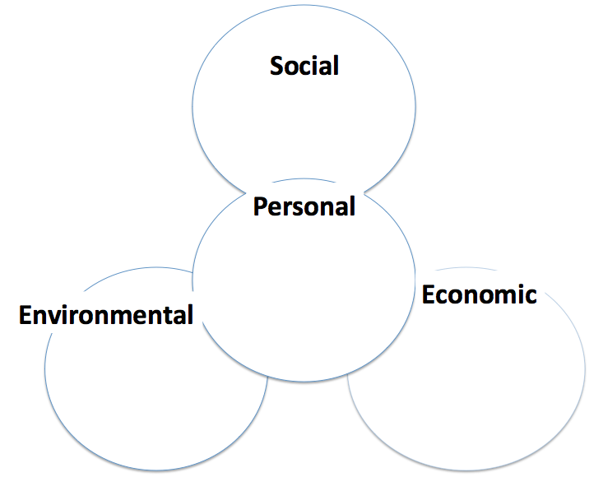

BRANDING
Unique Selling Points: Why Should We Buy Your Food?
Identify the key items that are unique to your farm business.
Use these key points in developing your messaging across all of your marketing platforms.
Narrow them down to the 4-6 bullet points that:
- Succinctly describing what you offer, and
- Aligns with what you have determined your target audiences’ need/value.

1
2
3
4
5
6

WEEK 4: Branding Tell Your Customer / Develop Relationship

Develop Your Story Material
- Brainstorm adjectives and descriptive phrases
- Images that illustrate your farm value’s and story
BACK STORY  The history of your farm | FACE OF THE FARM Characters  Signature Crops | SETTING  Location, crops, wildlife, weather. Tangible and sensory | Plot  What’s happening | Unique  Selling Points
Colors

Fonts

Tagline Brainstorm: Using your unique selling points, brainstorm taglines.

Boiler Plate Descriptions
• Articulate your business description and unique selling points in descriptions of lengths from 150 words to 20 words.
• Use these in print, business facebook /about description, at the end of a press release, in online business and membership directories, on your website.
• BE CONSISTENT with your messaging across all platforms!

© 2018 Atina Diffley

